PRESS RELEASE
Athens, 9 August 2022

“RIDE THE WAVE”: An Italian-Greek initiative to promote ocean and climate literacy in Nautical High Schools

Ocean and climate literacy is the ability to understand and explain in simple words issues such as the impact of our influence on the ocean and climate and the importance of ocean and climate for life on Earth, and human life in particular. It is also important to understand that with the term “ocean” we refer to the Global Ocean, the Blue Planet, which is to say all the interconnected oceans and seas of the Earth.

Now more than ever, it is a critical knowledge and skill to foster sustainable behaviors particularly among future sea professionals. For this reason, the Hellenic Marine Environment Protection Association - HELMEPA, together with the Italian environmental association Marevivo Onlus (project leader) and two high schools, the Nautical Institute "G. Da Verrazzano” in Porto Santo Stefano, Grosseto, Italy, and the 1st Vocational High School of Konistres in Evia, Greece, have partnered in the framework of the project “Ride the Wave”, to raise ocean and climate awareness with a special focus on Nautical High Schools students and teachers, but also among citizens and local communities.

The project “Ride the Wave” is funded by the Erasmus + EU's program (2021-2027) to support education, training, youth and sport in Europe and the reference Agency of the program is INDIRE (National Italian Institute of Documentation, Innovation and Educational Research). The project outputs include the development of ocean and climate literacy curricula for technical nautical high schools, the increase of teaching and learning capacity on these themes, as well as the involvement of local communities and maritime and marine protection stakeholders in the creation of a Local Sea Network, for the exchange of expertise and best practices on environmental education.

The activities have already started and will last until August 2023. You will find more information about the project and the partners involved in the official website and Facebook page

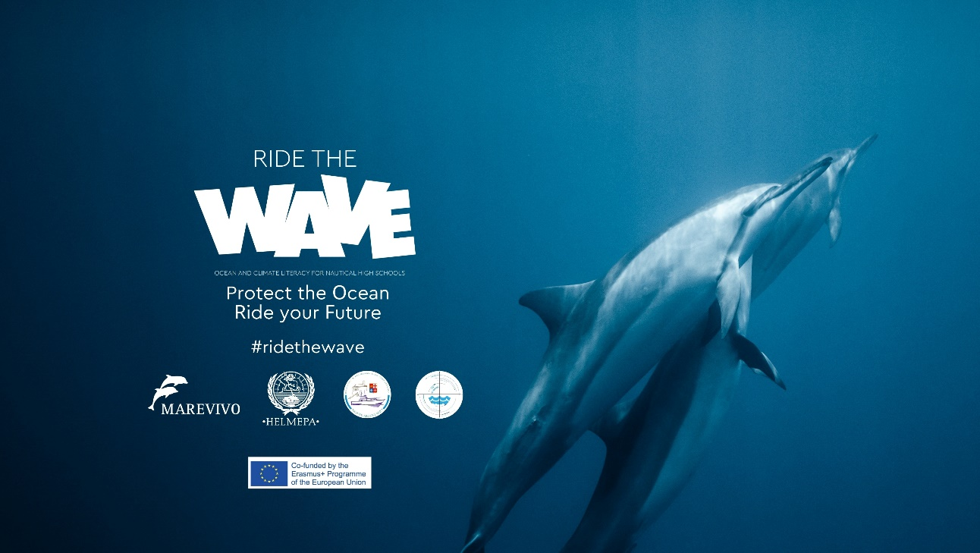

Media & Communications
Evdokia Gerasimou
egerasimou@helmepa.gr

